Bibliography of articles

Reading Articles Written Specifically for White Americans
To My White Friends Who See Tragedy in the Black Community and Say Nothing, Make it Personal, published by Huffington Post on June 26, 2015
‘We need co-conspirators, not allies’: how white Americans can fight racism, published by The Guardian on June 26, 2015
Be Less Racist: 12 Tips for White Dudes, by A White Dude, published by Mash-up Americans
7 Ways To Be A White Ally For Charleston And The Black Community, published by Huffington Post on June 19, 2015
10 Things All White Folks Need to Consider about the #BaltimoreUprising, published by Everyday Feminism on April 29, 2015
11 Things White People Can Do to Be Real Anti-Racist Allies, published by AlterNet on April 27, 2015
6 things I wish people understood about being biracial, published by Vox on March 11, 2015 (This one is not specifically addressed to White people but many would benefit from reading it.)
What white people need to know, and do, after Ferguson, published by The Washington Post on November 28, 2014
12 Things White People Can Actually Do After the Ferguson Decision, published by Huffington Post on November 26, 2014
To follow sources that publish such articles, find an extensive listing here. If these articles leave you with unanswered questions, there’s now even a website devoted to answering the questions of White Americans: askawhiteperson.com.

Understanding Whiteness, White Privilege, Microaggressions, and a History of Racial Discrimination
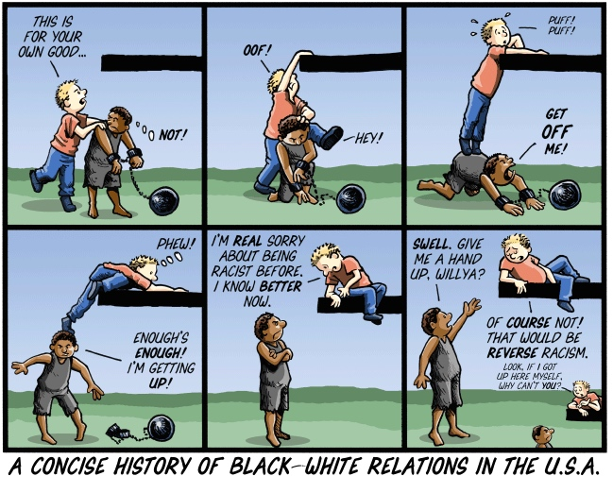
By Barry Deutsch
Native Americans Get Shot By Cops at an Astonishing Rate, published by Mother Jones on July 15, 2015
Slavery to Mass Incarceration, a five-minute video, narrated by Bryan Stevenson of the Equal Justice Initiative, that concisely contextualizes mass incarceration as an evolution of slavery, published on July 7, 2015
I, Racist: Why I don’t talk about race with White people, published by Medium on July 6, 2015
The Atlantic Slave Trade in Two Minutes, a short video that provides a “haunting” glimpse into the mass abduction, abuse, and murder of Black people that lasted centuries, published by Slate Magazine on June 25, 2015
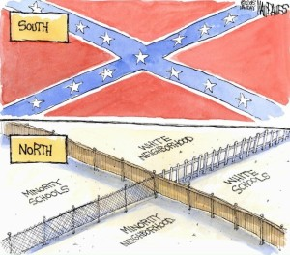What Is Whiteness?, published by The New York Times on June 20, 2015
We Need To Talk About White Culture, published by The Daily Beast on June 19, 2015
Historian Says Don’t ‘Sanitize’ How Our Government Created Ghettos, a 35-minute interview with Historian Richard Rothstein, in which he links current racial inequities directly to past governmental policies, from NPR’s Fresh Air on May 14, 2015
If Anyone Ever Questioned How White Privilege Manifested Itself in America This Is The Perfect Illustration, a five-minute video excerpt showing that, though race is a social construction with no scientific basis, governmental policy systematically gave it social and economic significance–all to the benefit of White Americans over the course of centuries–from Atlanta Blackstar on May 2, 2015
White Fragility: Why It’s So Hard to Talk to White People About Racism, published by The Good Men Project on April 9, 2015
Only Part of the Story Is Being Told About the Police Shooting in Pasco, published by Time on March 3, 2015
Our Anti-Immigrant Racism Is Rooted in History, published by Common Dreams on February 17, 2015
Killing in Washington State Offers ‘Ferguson’ Moment for Hispanics, published by The New York Times on February 16, 2015
We Can’t ‘Get Over It’: 4 Ways Understanding Past Wrongs Can Create Better Indigenous Allies, published by Everyday Feminism on January 15, 2015
Why Ferguson Should Matter to Asian-Americans, published by Time on November 26, 2014

Joining Groups
Coalition of Anti-Racist Whites (CARW): a group of white people in the Seattle area working to undo institutional racism and white privilege through education and organizing in white communities and active support of anti-racist, people of color-led organizations. We support the self-determination of people of color, honor their leadership and are held accountable to people of color-led organizations.
European Dissent: A national network of groups with the goal to be a visible force in the creation of a multiracial network of people intent on building working relationships between the white community and the communities of color in the struggle for a just society.
Showing Up for Racial Justice (SURJ): A national network of groups and individuals organizing white people for racial justice.

Parenting Racially-Conscious Children
How silence can breed prejudice: A child development professor explains how and why to talk to kids about race, published by The Washington Post on July 6, 2015

It’s My Job to Raise Children Who Are Not Only Not Racist But Actively Anti-Racist, published by Huffington Post on July 1, 2015

The Hard Talk: White Parents Discussing Racism with White Children, published in Uprooting Criminology on June 20, 2015

